FboLinx Architecture
First Draft

FBOLinx is using a Layer architecture which consist of the following main layers
- FBOLinx.Web
  - Provides an interface to the user. Uses the ServiceLayer to achieve user interactions.
Contains all code related to the presentation layer, client related framework, API controllers, and middleware used on the net core pipeline
- FBOLinx.Core
  - This project contains the business object and rules.
- FBOLinx.ServiceLayer
  - This project has all the business logic of the application
- FBOLinx.DB
  - This project contains data base related classes such as entities, specifications and migrations.
FBOLinx use the most common patterns used on a modern application, such as
- dependency injection - using the net core in build injection IOC
- Repository pattern – an abstraction of the db interaction into reusable classes
- Object Relational Mapping pattern - Use Entity framework to map objects from database.
- Data Tranfer Object Pattern - known as DTO to transfer information between different layers, to achieve this we are using Mapster to map between objects.
https://github.com/MapsterMapper/Mapster

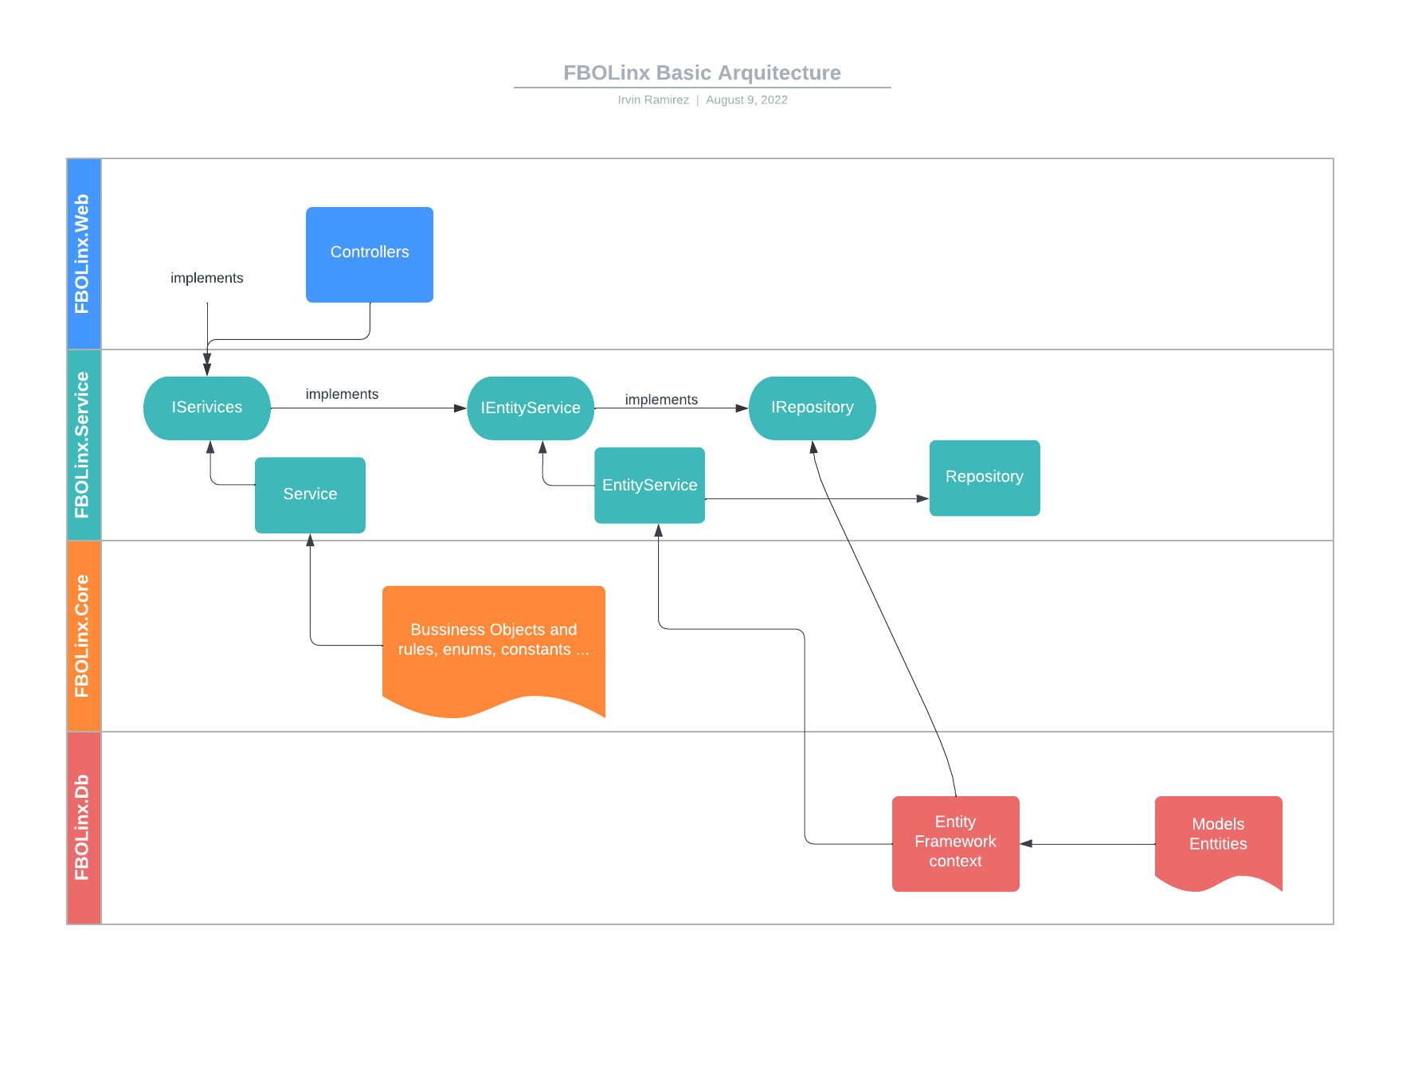
Examples classes of FBOLinx Request flow
Controller
...\FBOLinx.Web\FBOLinx.Web\FBOLinx.Web\Controllers\PricingTemplatesController.cs

Service
...\FBOLinx.Web\FBOLinx.Web\FBOLinx.ServiceLayer\BusinessServices\PricingTemplate\PricingTemplateService.cs
EntityService
...\FBOLinx.Web\FBOLinx.Web\FBOLinx.ServiceLayer\EntityServices\PricingTemplateEntityService.cs
Repository
...\FBOLinx.Web\FBOLinx.Web\FBOLinx.ServiceLayer\EntityServices\Repository.cs

Repository pattern implementation
FBOLinx uses multiple databases to get information, to be able to use the repository pattern with different dtabases, it get the context that will be used as on a generic implementation along with the entity that will be used to return data as the following code
public interface IAcukwikFbohandlerDetailEntityService : IRepository<AcukwikFbohandlerDetail, FboLinxContext>
{
}

public class AcukwikFbohandlerDetailEntityService : Repository<AcukwikFbohandlerDetail, FboLinxContext>, IAcukwikFbohandlerDetailEntityService
{
}

